Game Design Document Revised

Sai Tanmay, Prerna, Radhika

Title

1. Game Name : Amnesiac’s Odyssey

A zombie apocalypse mystery.

Game Overview

* 1. Game Concept:

A cyborg with no memory of the past tries to solve the mystery of his own origin, explores a zombie ridden world and discovers the dark truths behind the apocalypse.

* 1. Genre:

Puzzle-based, exploratory, RPG, mystery

* 1. Target Audience:

Early teenagers(11-13), Teenagers(14-17)

* 1. Game Flow Summary – How does the player move through the game. Both through the framing interface and the game itself.

The player starts at a location without any memory. Moves around his position to find clues that the player may have to use in some other location. Clues also direct him to visit one location to another on the map. The player physically moves from one location to another while facing zombies on the way. -To Be Edited-

* 1. Look and Feel – What is the basic look and feel of the game? What is the visual style?

The look resembles archaic 16 bit graphics with a revamp of Modern graphics. The game uses a 2D open world map system.

Gameplay and Mechanics

* 1. Gameplay
     1. Game Progression
        1. The game is mainly set on three islands. At each island, the player gets clues by exploring artifacts/clues with various narratives that tell him about his identity and about the vaccine at the end.
        2. Zombies are encountered in the main world at random locations. The player may choose to attack and defeat the zombie, or forfeit and run away from it. These considerations can be made on the basis of the player's remaining health.
     2. Mission/challenge Structure
        1. The challenge is to find all clues, get a reasonable explanation for his amnesia, recover his memories and save the human race, or what’s left of it.
        2. Along the way, he must fight off zombies, which chip off on his health points, or save himself and run. If the player’s health hits zero, the player loses the game.
     3. Puzzle Structure
        1. The puzzle is in recognising objects out of place(clues, artifacts) and figuring out the narratives to get to other clues.
        2. As information is revealed about each clue, the names of islands, passwords and other crucial information are present in the narrative itself, embedded as word plays or anagrams.
     4. Objectives – What are the objectives of the game?
        1. To reveal the person’s history and in the process also discovering the cure/vaccine to the zombie pandemic.
        2. The minor objective of the game is to fight off zombies and reserve health points.
     5. Play Flow – How does the game flow for the game player
        1. The game flow is best if linear. The player starts at a scene and gets dropped in the main world at a particular location. The player may, if she chooses to, move around and explore the world. While exploring, the player will encounter zombies.
        2. However, all locations other than the storage room can be explored in any order.
        3. The storage room needs clues from the previous locations(a burnt house, a lab, a hideout, etc). Only by unlocking the vaccine can the player finish the game.
  2. Mechanics – What are the rules to the game, both implicit and explicit. This is the model of the universe that the game works under. Think of it as a simulation of a world, how do all the pieces interact? This actually can be a very large section.
     1. Physics – How does the physical universe work?
        1. When the game starts, the player finds himself in a ship corridor. The player finds a brochure necessary for the future steps.
        2. After finding and downloading the Map, he enters the main world.
        3. In the main world, there are two types of terrains-Land and Water. The various islands consist of the land in the game. Locations are on different islands. We can also travel through water using a sailboat readily available at our disposal whenever we plunge into water.
        4. The game is designed to be in 2D, so the player can explore the grid/map with exception to places marked by black in the mask.
        5. Islands like Rochelle, Teshlor and Aquesha have specific locations which are marked on the map and are accessible with clues hidden in them.
        6. Zombies can attack while you’re at sea or on any particular island. The zombies are spawned at random and do not follow any herd behaviour.
        7. The location in Rochelle has a click based clue identification, whereas in other locations the clues are triggered when the player moves near them.
     2. Movement in the game:-

When the player is in the ship/Land:- Use Left/Right/Up/Down arrow keys to move in the left, right, upward and downward direction relative to the screen respectively.

While travelling on water- sail boat can be used which has the same controls- Left/Right/Up/Down.

Entrances to locations on the island are triggered when the player walks near them. The scheme then opens in the new place.

* + 1. Objects – how to pick them up and move them There are two types of features implemented.

In certain locations, the player needs to arrive at a point near the object and the object is automatically added to the inventory. In the Second type of feature implementation, Player needs to hover over the object to get its description and then click on it to add it to the inventory.

* 1. Actions, including whatever switches and buttons are used, interacting with objects, and what means of communication are used:-

Actions/ switches/buttons used:- We use the arrow keys or the W, A, S, D keys to move the player. For click based scenes, we use the right click on the mouse on the object to pick up the item. In combat, we use mouse clicks to choose between, attack and forfeit in this turn based combat implementation.

To Interact with the objects:-

By hovering over the object, The description of the objects is displayed as a message on the screen. Picking up an object may trigger a narrative which gives us further clues. The picked up objects are placed in the inventory with a description for later reference during the game.

Means of communication:-

We communicate with the player with the narrative we provide. Our screen also includes an inventory, a map and a health bar for the player.

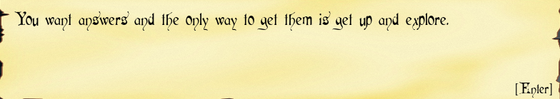

Combat – If there is combat or even conflict, how is this specifically modeled? :-

While finding clues, zombies attack at random locations and we use guns for combat. There are health points for a player and zombie. The zombie attacks after the first turn from the player. The attacks are modelled as a random value between 2 values for the zombie, which are chipped off of the player’s health after each attack. Whereas the player has a set attack power. If the zombie’s health depletes, the zombie is defeated. If the player’s health depletes, the player must restart the game.

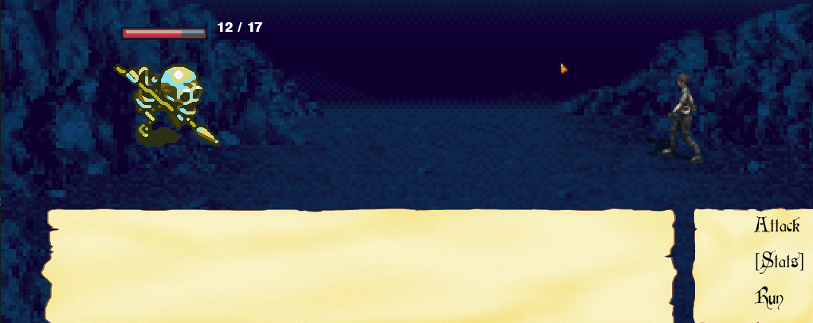

* 1. Economy – What is the economy of the game? How does it work?:-

The economy of the game is in health points. The player must have adequate health to continue playing the game. One way to do this is to avoid conflict and forfeiting the zombie fights and getting out with minimal damage.

* 1. Screen Flow -- A graphical description of how each screen is related to every other and a description of the purpose of each screen:-

The game screen is the primary screen in our game. Various scenes are displayed on it based on the progress made by the player. The screens of importance are that of inventory and map. We can view all collected items and a brief description of them in the inventory. The next is the map, with a red dot to represent the player in the world, to guide the player to different places on the map. If the player is in a different scene than the main world, the map shows the player to be at the entrance of that location.

Game Options – What are the options and how do they affect game play and mechanics? :- In the game, during finding the clues the player comes across zombie attacks as a part of combat of the game. There are two options in this case. Fight/Run. If the player fights, the zombie will slowly chip off on the player’s health. But the attack power for the player is quite higher than that of a zombie, thus giving an advantage to the player. If the player runs, the player gets out of the combat with minimal or no damage.

Replaying and Saving:

If the player’s health points run out, the player’s data is saved and can be restored using the load game option. A new player can choose to start a new game.

Cheats and Easter Eggs:

None. 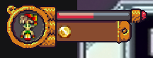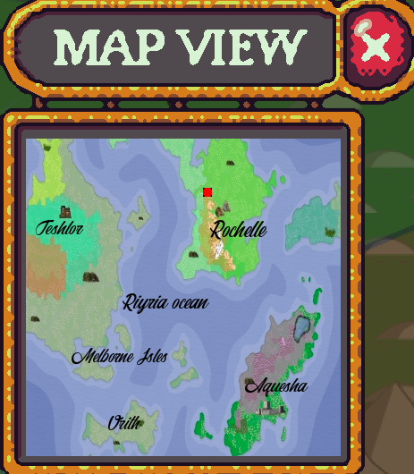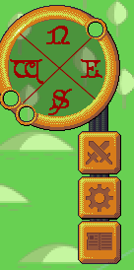

4- Story, Setting and Character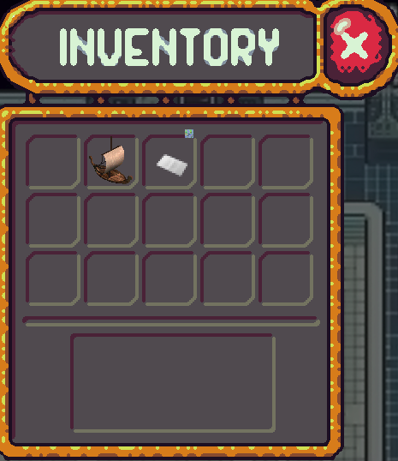

* 1. Story and Narrative – Includes back story, plot elements, game progression, and cut scenes. Cut scenes descriptions include the actors, the setting, and the storyboard or script
     1. Back story - The player is a friend and a fellow bio-engineer experimenting with viruses. One of the experiments release the zombie virus into the world and starts the pandemic. The player loses her memory in a freak accident and is given cyborg parts in hopes of reviving her by her colleagues. The player wakes up on a ship bound for Rochelle. She was put there by her colleagues in hopes of better treatment there.
     2. Plot elements -
        1. The player starts on a ship corridor where the player finds a brochure. The brochure is of the ship he’s on with something scribbled on it. Cel hero. This is an anagram for Rochele.
        2. Then the player goes to the ship cabin where he receives the world map. After receiving the world map, the player can then move on to the main world where he lands in Rochele near a hideout.
        3. Upon exploring the hideout, he receives 2 letters. The letters are exchanged between one Doctor Nevlin, and one Doctor Gwen. They’re discussing the zombie apocalypse and mention a lab in Teshlor. The rest of it is gibberish with the word NEVLIN repeating several times.
        4. Upon reaching Teshlor, the player finds a burnt house. He finds a key and a laptop in the drawing room of the same. The laptop is mostly broken, but the player finds a news footage mentioning the rising number of zombies and mentions Aquarelle.
        5. Upon exploring further the player finds the dungeon and then the lab. Where he discovers that she is one of the creators of the zombie virus. And she was also working on a cure/vaccine for the same before it was released into the world. She has a genetic mutation that made her immune to the virus.
        6. Upon reaching Aquarelle, she finds a bunker. Upon entering the player finds a safe. The safe asks for a password. The password is NEVLIN typed onto a numpad. The player then uses the key found in the burnt house to open the safe and finds the cure/vaccine. Then the player sets out to rescue the remaining population of the world.
     3. Game progression - As the player moves forward, he realises the past as well as gets a clue for the next step.
     4. Script: <https://docs.google.com/document/d/1lDQmAAUNAU-PrZDYPQY-jMH7yK6qcmQ2nU77M5M4Vwk/edit>
  2. Game World
     1. The game is set in a fictional world with 3 main islands. These are visible in the map shown above.
     2. Various Islands are:
        1. Rochele: has the hideout, can be accessed by sea.
        2. Teshlor: has the Burnt house under which is the player’s former lab.
        3. Aquarelle: has the bunker with the cure/vaccine in a safe
  3. Characters.

We only have one character. Her name is Esra Stryker. She discovers her past in Teshlor, when she discovers the lab. She is a cyborg in the present, but a human previously. She is a bio-engineer experimenting on various viruses. She has friends, who were also her colleagues. They saved her after a freak accident and made her into a cyborg. She’s rational, practical and has moral values.

5- Levels

a- Levels. Each level should include a synopsis, the required introductory material (and how it is provided), the objectives, and the details of what happens in the level. Depending on the game, this may include the physical description of the map, the critical path that the player needs to take, and what encounters are important or incidental.

1. Levels are not clearly defined as it is a continuous story based rpg.
2. We can divide the game into 4 levels, one at each location.
3. Level 1 - to get the map from the ship cabin
4. Level 2 - to get the clues from the hideout in Rochele
5. Level 3 - to get the key and rediscover lost memories at the burnt house in Teshlor
6. Level 4 - to unlock the vaccine in Aquarelle
7. Of these 1 and 4 must be first and last respectively but 2 and 3 may be interchanged.

b- Training Level

The training level is in the ship cabin. We provide both the clue and answer to make the player understand what to do.

6- Interface

* 1. Visual System. If you have a HUD, what is on it? What menus are you displaying? What is the camera model?
     1. HUD - The HUD is displayed on top of the screen . It contains a bar showing the player’s health and points collected.
     2. Menus - We have a help menu, along with a map and inventory menu.
  2. Control System – How does the game player control the game? What are the specific commands?
     1. The player uses the arrow keys(or asdw) to control the game.
     2. We display inventory which displays all collected objects.
     3. A map shows the players current location
  3. Audio, music, sound effects
     1. The music is mysterious, haunting and intriguing. It is kept on the subtle side to focus on the gameplay.
     2. There is a unique looping audio corresponding to each location and fight scenes.
     3. Authentic gunshot and zombie sound effects were used in fight scenes.
  4. Help System:

N/A

1. Artificial Intelligence
   1. Opponent and Enemy AI – The active opponent that plays against the game player and therefore requires strategic decision making
      1. Zombies are the opponents. The fights are randomly generated. Each attack of the player causes both the zombie and player to lose some health points. The fight ends when the zombie is defeated.
   2. Non-combat and Friendly Characters
      1. The two characters. Dr.Gwen and Dr.Nevlin are explored only through backstories. They set out the clues for the player.
   3. Support AI -- Player and Collision Detection, Pathfinding
      1. Player and Collision detection - For this we have used blit masks for each scene to define the areas which can be explored and which can’t. If a player collides with a clue, he can pick it up.
      2. Pathfinding - For this we display a miniature map with a red dot representing his location. It can be accessed through the map button on the right.
2. Technical
   1. Target Hardware
      1. Currently the target hardware is PC only. It can easily be extended to Xbox etc controllers.
   2. Development hardware and software, including Game Engine
      1. PC hardware was used in the development of the system.
      2. Python(3+) and Pygame library softwares were used.
      3. Photoshop was used to create masks for each location.
      4. Fantasy map generator software was used to create the map.
      5. Github was used to maintain the code.
   3. Network requirements
      1. No network requirements as such.
3. Game Art – Key assets, how they are being developed. Intended style.
   1. Currently, we are developing new game assets related to scene animation and zombie attacks.
   2. The intended style is dark , futuristic and mysterious.